Task 2

1. **Target Device:** The platform for this game is Windows.
2. **Gameplay Flowcharts:**

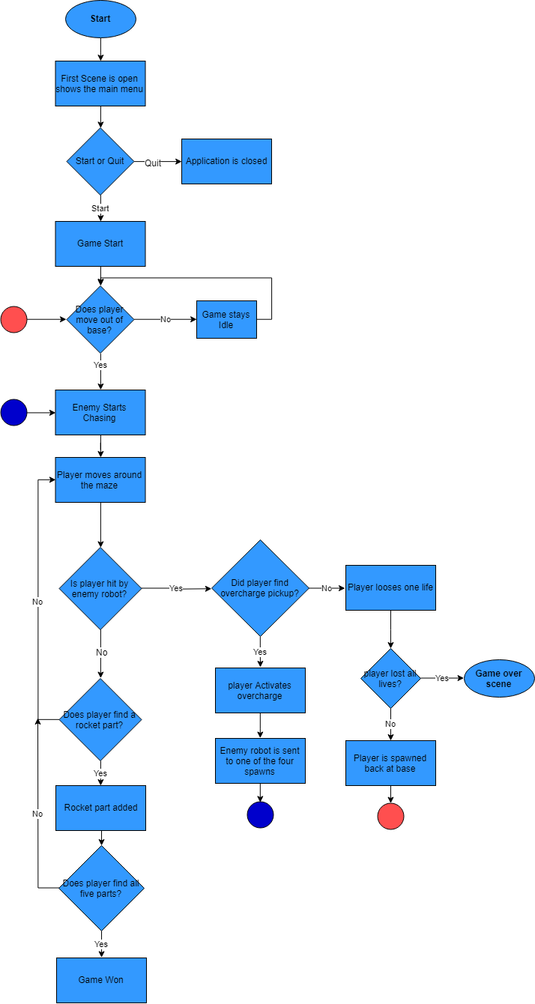

1. **Game Mechanics: There is a total of 4 major mechanics:**
   1. Player Movement – the ability to move forward and backward and turn left and right.
   2. Player has the ability to collect rocket parts.
   3. Player has the ability to activate a self-protection (OverCharge) for 10 seconds – this will be available when the player picks up the object and will activate with the space button.
   4. Artificial intelligence will follow the player by using a system called nav-mesh.
2. **Game Objectives:** The objective of this game is for the player to try and collect the spaceship parts without being caught from the enemy AI so he can escape.
3. 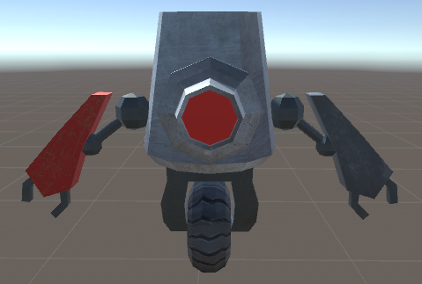**Visual Assets :**

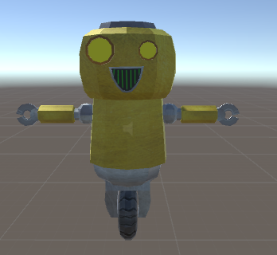

Model 2: Enemy (The enemy model)

Model 1 : Roll-E (The player model)

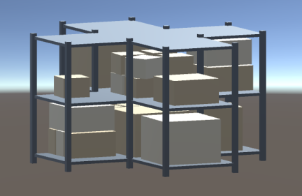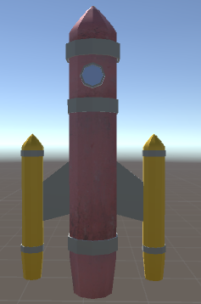

Model 4 Shelves-1

Model 3: The rocket ship

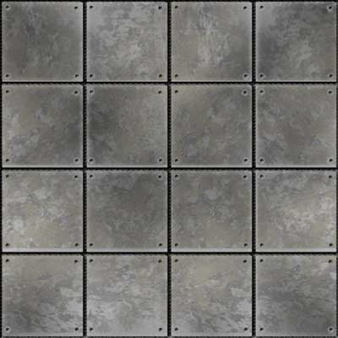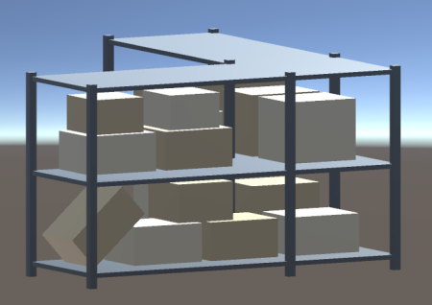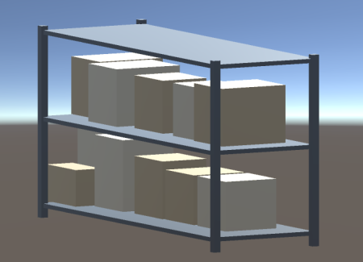

Model 4 Shelves-3

Model 4 Shelves-2

Metal Floor Texture

1. **Ui Elements :**

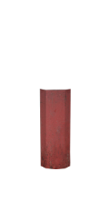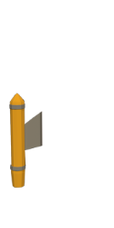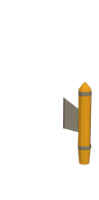

Background for Rocket Parts

Mini Map

Rocket ship parts

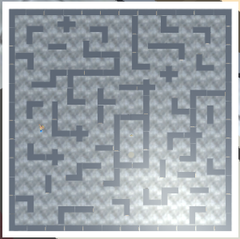





Life hearths

Power Up



Background for Hearths and power ups

1. **Game Scenes : Main Menu**

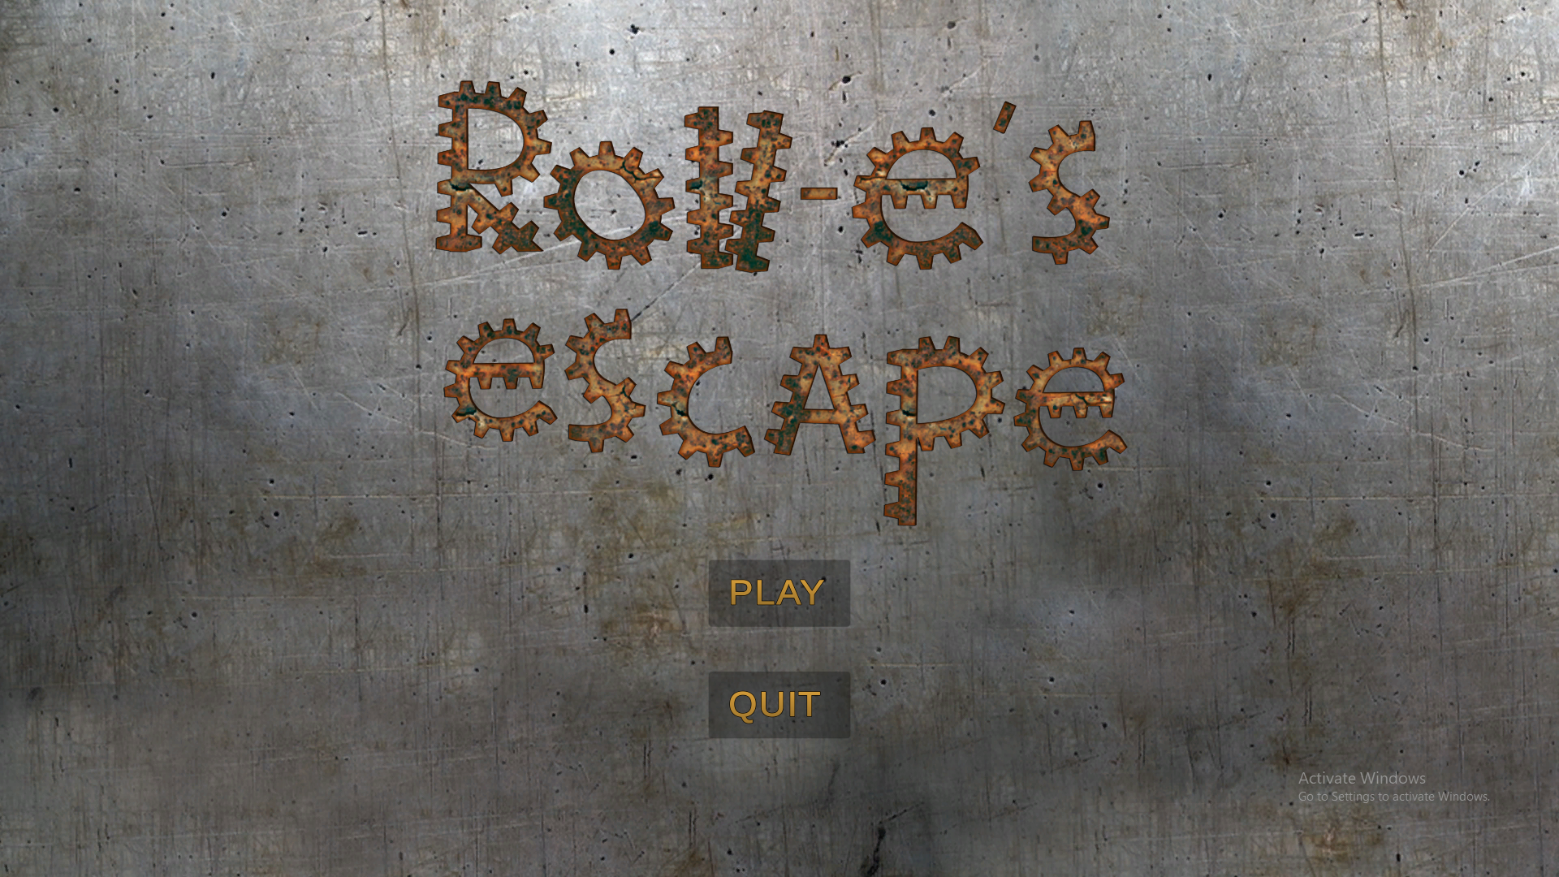

Tutorial Page

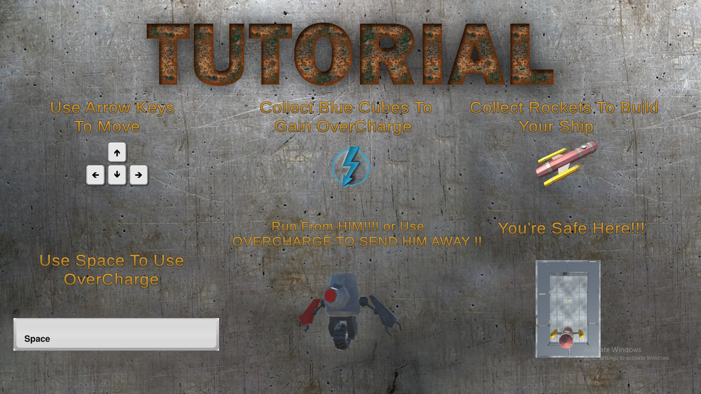

Main Game

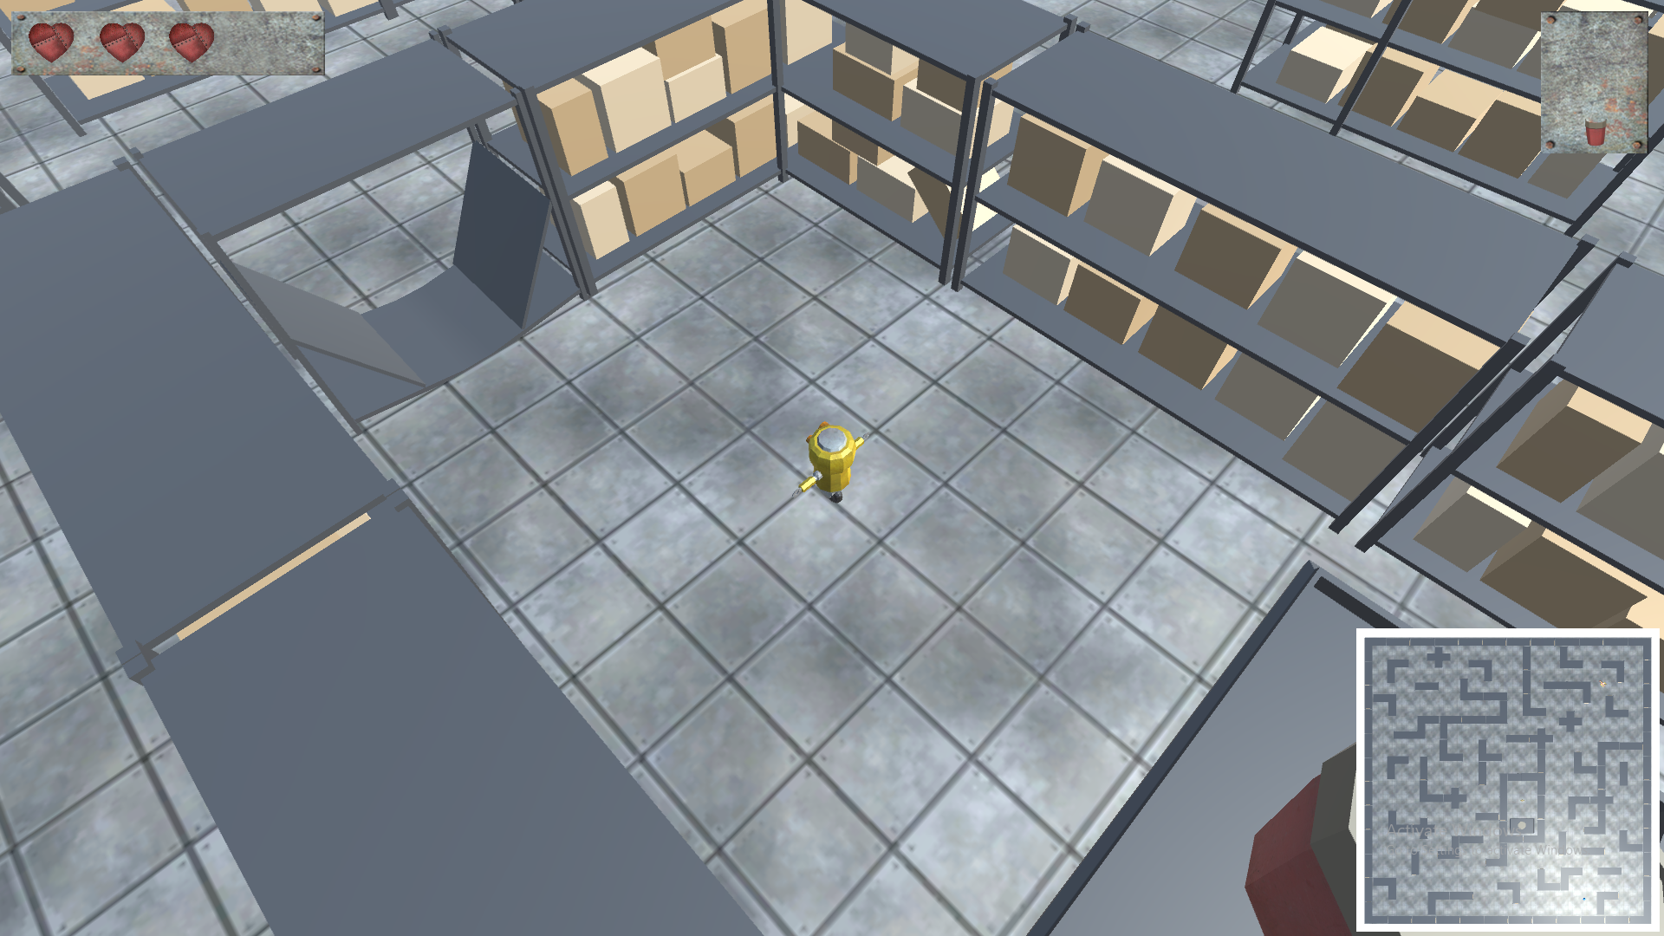

**Game Over screen**

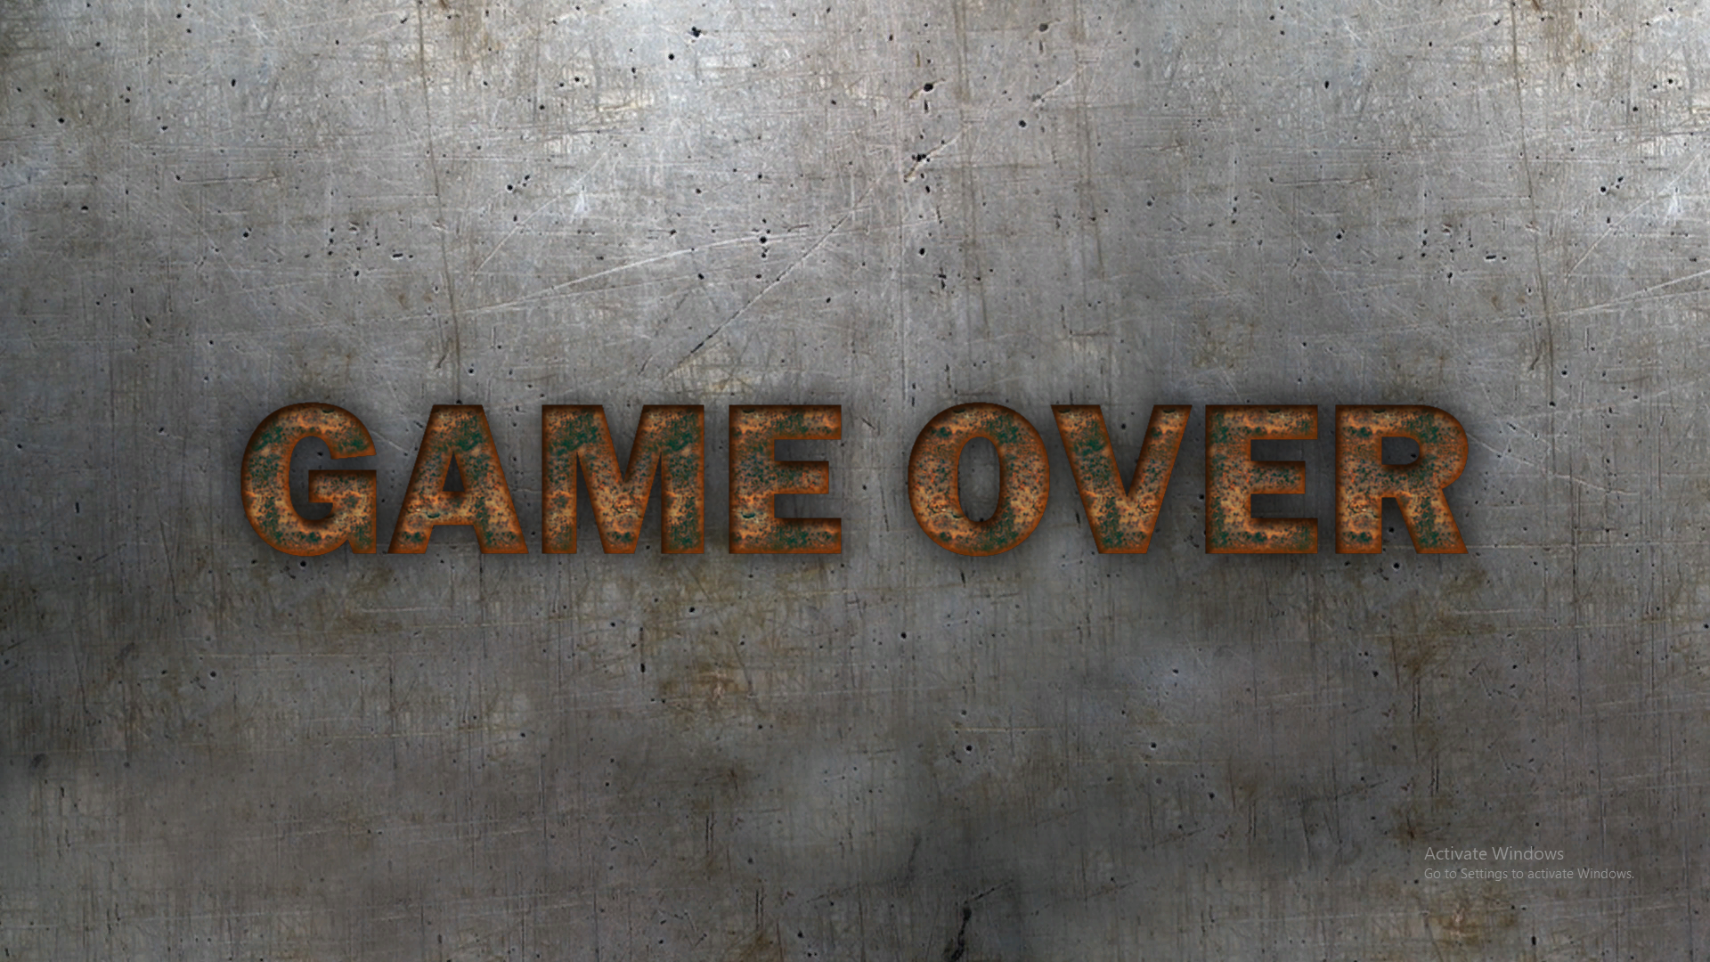

**Winning screen**

